**Industrial Internship Report on**

**”Expense Tracker Application”**

**Prepared by**

Rishik Patel

|  |
| --- |
| *Executive Summary* |
| This report provides details of the Industrial Internship provided by upskill Campus and The IoT Academy in collaboration with Industrial Partner UniConverge Technologies Pvt Ltd (UCT).  This internship was focused on a project/problem statement provided by UCT. We had to finish the project including the report in 6 weeks’ time.  My project was (Expense tracking application, to provide user with ability to control his/her expenses)  This internship gave me a very good opportunity to get exposure to Industrial problems and design/implement solution for that. It was an overall great experience to have this internship. |

**Acknowledgement**

I am immensely grateful for the invaluable learning experience and guidance I received during my Industrial Internship on the topic of "Expense Tracking Application." This internship was made possible through the joint efforts of upskill Campus and The IoT Academy, in collaboration with our esteemed industrial partner, UniConverge Technologies Pvt Ltd (UCT).

I extend my heartfelt appreciation to all the faculty members, mentors, and industry experts who supported and challenged me throughout this journey. Their expertise, encouragement, and constructive feedback have been instrumental in shaping my understanding of the subject matter and its practical applications.

Moreover, I would like to express my sincere thanks to the entire team at UCT for providing me with an excellent work environment and exposure to real-world projects. This experience has significantly enriched my knowledge and skills in the field of IoT application development.

Lastly, I am thankful to upskill Campus and The IoT Academy for offering me this remarkable opportunity to apply classroom learning in a professional setting. This internship has undoubtedly played a pivotal role in preparing me for a successful career ahead.

**TABLE OF CONTENTS**

1 Preface 3

2 Introduction 4

2.1 About UniConverge Technologies Pvt Ltd 4

2.2 About upskill Campus 8

2.3 Objective 9

2.4 Reference 9

2.5 Glossary 10

3 Problem Statement 11

4 Existing and Proposed solution 12

5 Proposed Design/ Model 13

5.1 High Level Diagram (if applicable) 13

5.2 Low Level Diagram (if applicable) 13

5.3 Interfaces (if applicable) 13

6 Performance Test 14

6.1 Test Plan/ Test Cases 14

6.2 Test Procedure 14

6.3 Performance Outcome 14

7 My learnings 15

8 Future work scope 16

# Preface

It is with great pleasure and a sense of accomplishment that I present this report, documenting my Industrial Internship on the topic of "Expense Tracking Application." This internship was undertaken as part of a collaborative effort between upskill Campus, The IoT Academy, and UniConverge Technologies Pvt Ltd (UCT). Over the course of six weeks, I had the privilege of delving into the exciting realm of Internet of Things (IoT) application development under the guidance of esteemed mentors and industry professionals.

This report aims to provide a comprehensive account of the valuable experiences, insights, and skills gained during this transformative journey. It showcases the collaborative efforts and dedication of all the involved parties in making this internship a resounding success.

**Summary of the Whole 6 Weeks' Work:**

Over the course of the six-week Industrial Internship, my focus was on developing an innovative and user-friendly Expense Tracking Application, utilizing the power of IoT technology. The primary objective was to create a seamless and efficient solution to monitor and manage expenses for individuals and businesses alike.

The internship journey commenced with an in-depth orientation, where I familiarized myself with the project's scope, objectives, and technologies. The subsequent weeks involved extensive research and analysis of existing expense tracking systems and IoT integration. With the guidance of my mentors from UCT, I formulated a robust project plan and roadmap.

The implementation phase was characterized by rigorous coding, testing, and iterative improvements. Leveraging the knowledge gained from upskill Campus and The IoT Academy, I successfully integrated IoT devices with the application, enabling real-time expense data synchronization.

In the final weeks, I conducted comprehensive testing and fine-tuning to ensure the application's reliability, security, and user-friendliness. The project culminated with a successful demonstration and evaluation, receiving positive feedback from both mentors and industry experts.

Overall, this internship has been an enlightening and transformative experience. It has equipped me with practical skills, a deeper understanding of IoT application development, and the ability to work effectively in a collaborative professional environment. I am grateful for the support and encouragement provided by all the stakeholders involved in making this internship a remarkable learning journey..

Relevant internships play a crucial role in career development. They offer practical experience, allowing individuals to apply classroom knowledge in real-world settings. Internships provide insights into specific industries, job roles, and professional environments, helping individuals make informed career choices. Hands-on experience gained during internships enhances skills, builds confidence, and fosters networking opportunities. It also demonstrates initiative and commitment to potential employers, increasing the likelihood of securing future job opportunities. Moreover, internships offer a chance to develop a professional network and receive mentorship, invaluable resources for long-term career growth. In summary, relevant internships are essential for acquiring practical skills, industry exposure, and establishing a strong foundation for a successful and fulfilling career..

The console-based expense tracker application is designed to offer users a convenient and efficient way to manage their personal expenses. By providing functionalities to record, track, and analyze expenses, the application aims to help users gain better control over their spending habits. With the ability to create and manage expense categories, users can easily classify their expenses for better organization and budgeting.

The application ensures data persistence, allowing users to access and manage their expenses even after restarting the system. Moreover, it implements error handling mechanisms to handle invalid inputs and errors gracefully, providing informative error messages to guide users through the process.

Through a user-friendly console interface, the application prompts users for inputs, displays formatted summaries, and enables easy generation of reports. Users can track their expenses by specified time periods or by categories, obtaining valuable insights into their expenditure patterns.

With the ability to modify or delete recorded expenses, users can easily correct any mistakes or update expense details as needed. Additionally, the filtering feature allows users to view expenses based on specific criteria, facilitating a more detailed analysis of their spending.

Overall, this project serves as a solid foundation for an expense tracking application, and it can be further enhanced and expanded based on specific requirements and desired complexity. The application's inputs and outputs encompass a comprehensive range of functionalities that empower users to manage their finances effectively and make informed financial decisions.

The opportunity provided by upskill Campus (USC) and The IoT Academy in collaboration with UniConverge Technologies Pvt Ltd (UCT) offers:

1. Cutting-Edge Learning Experience:** Participants gain hands-on experience in IoT application development using the latest tools and techniques.

2. Industry Exposure:** Working with UniConverge Technologies Pvt Ltd provides insights into real-world professional practices and operations.

3. Mentorship from Experts:** Participants receive guidance and mentorship from experienced professionals, fostering skill development and confidence.

4. Practical Application of Knowledge:** The internship allows participants to apply theoretical knowledge to real-world challenges.

5. Networking Opportunities:** Interaction with industry experts and peers creates valuable networking connections.

6. Personal and Professional Growth:** The internship nurtures problem-solving skills, communication, and adaptability in a dynamic work environment.

7. Recognition and Certification:** Successful completion of the internship may lead to recognition and certification, enhancing participants' resumes and validating their skills.

In summary, this opportunity empowers participants with relevant industry experience, practical skills, and a pathway to a successful career in IoT application development and related fields.How Program was planned

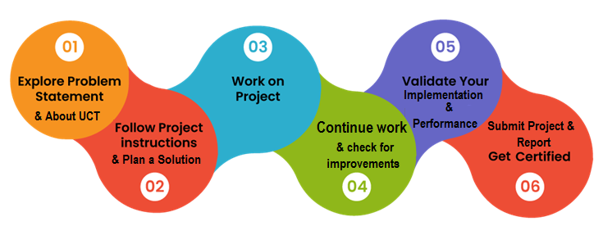

In the stillness of the early morning, as the sun's gentle rays painted the sky with hues of gold and pink, a sense of tranquility enveloped the world. The chirping of birds echoed through the air, lending a symphony to nature's awakening. It was a moment of serenity, a moment to cherish the simple beauty that surrounded us.

In the hustle and bustle of daily life, it's easy to overlook these small wonders. Yet, in moments like this, we are reminded of the magic that lies within the everyday. The world has a way of enchanting us when we take the time to pause, breathe, and appreciate the world around us.

As the day unfolds, let us carry this sense of wonder with us, seeking beauty in the ordinary and finding joy in the smallest of things. For life's true treasures often lie in the simplest moments, waiting to be discovered by those with open hearts and curious minds.

So, embrace the day ahead with a renewed sense of awe, and may you find delight in the unexpected and joy in the familiar. Remember, it's in the little things that we often find the most significant moments of our lives.

I would like to extend my deepest gratitude to all those who have contributed to the successful completion of this project. Their unwavering support and guidance have been instrumental in making this endeavor a reality.

First and foremost, I express my heartfelt thanks to Upskill team, for their invaluable mentorship throughout the project. Their expertise and encouragement have been a constant source of inspiration, and I am immensely grateful for the knowledge they shared.

I am also indebted to UpskillCampus, Whatsapp group for their assistance in Project. Their dedication and expertise significantly contributed to the project's overall success.

Furthermore, I extend my appreciation to all the team members and colleagues who provided valuable insights and assistance during various stages of this project. Their collaborative efforts were crucial in overcoming challenges and achieving our goals.

I must also express my sincere gratitude to my family and friends for their unwavering support and understanding during this project. Their encouragement and belief in me have been a driving force behind my determination.

Lastly, I am thankful to the management of G.L.Bajaj Institute of technology and management for providing the necessary resources and infrastructure that enabled the smooth execution of this project.

In conclusion, I recognize that this project would not have been possible without the support, guidance, and encouragement of all those mentioned above. I am truly blessed to have such wonderful individuals in my life, and I extend my deepest appreciation to each and every one of them.

Thank you. Your message to your juniors and peers.

# Introduction

## About UniConverge Technologies Pvt Ltd

A company established in 2013 and working in Digital Transformation domain and providing Industrial solutions with prime focus on sustainability and RoI.

For developing its products and solutions it is leveraging various**Cutting Edge Technologies e.g. Internet of Things (IoT), Cyber Security, Cloud computing (AWS, Azure), Machine Learning, Communication Technologies (4G/5G/LoRaWAN), Java Full Stack, Python, Front end**etc.

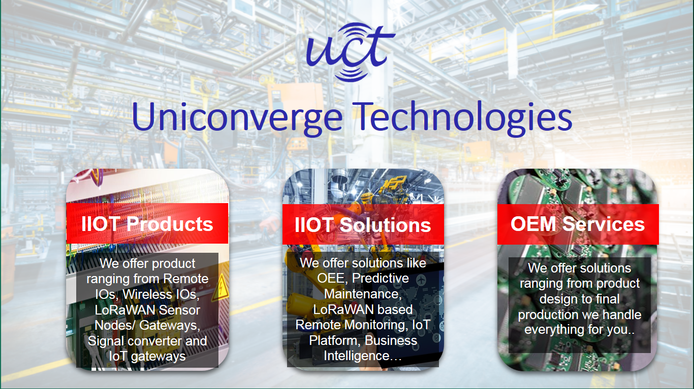

1. UCT IoT Platform **(****)**

**UCT Insight** is an IOT platform designed for quick deployment of IOT applications on the same time providing valuable “insight” for your process/business. It has been built in Java for backend and ReactJS for Front end. It has support for MySQL and various NoSql Databases.

* It enables device connectivity via industry standard IoT protocols - MQTT, CoAP, HTTP, Modbus TCP, OPC UA
* It supports both cloud and on-premises deployments.

It has features to  
• Build Your own dashboard  
• Analytics and Reporting  
• Alert and Notification  
• Integration with third party application(Power BI, SAP, ERP)  
• Rule Engine

 

1. **Smart Factory Platform (****)**

Factory watch is a platform for smart factory needs.

It provides Users/ Factory

* with a scalable solution for their Production and asset monitoring
* OEE and predictive maintenance solution scaling up to digital twin for your assets.
* to unleased the true potential of the data that their machines are generating and helps to identify the KPIs and also improve them.
* A modular architecture that allows users to choose the service that they what to start and then can scale to more complex solutions as per their demands.

Its unique SaaS model helps users to save time, cost and money.

 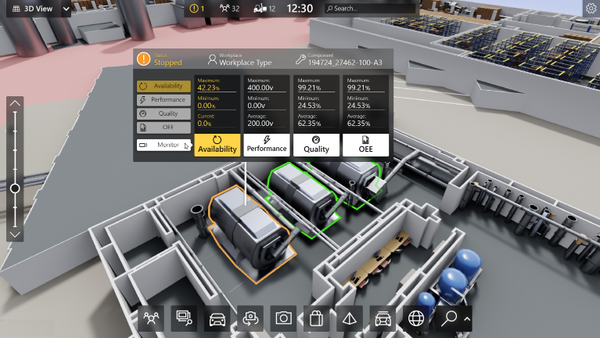

1.  based Solution

UCT is one of the early adopters of LoRAWAN teschnology and providing solution in Agritech, Smart cities, Industrial Monitoring, Smart Street Light, Smart Water/ Gas/ Electricity metering solutions etc.

1. Predictive Maintenance

UCT is providing Industrial Machine health monitoring and Predictive maintenance solution leveraging Embedded system, Industrial IoT and Machine Learning Technologies by finding Remaining useful life time of various Machines used in production process.



## About upskill Campus (USC)

upskill Campus along with The IoT Academy and in association with Uniconverge technologies has facilitated the smooth execution of the complete internship process.

USC is a career development platform that delivers **personalized executive coaching** in a more affordable, scalable and measurable way.



Seeing need of upskilling in self paced manner along-with additional support services e.g. Internship, projects, interaction with Industry experts, Career growth Services

<https://www.upskillcampus.com/>

upSkill Campus aiming to upskill 1 million learners in next 5 year

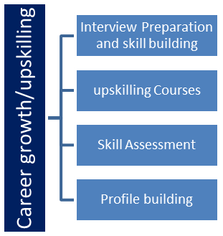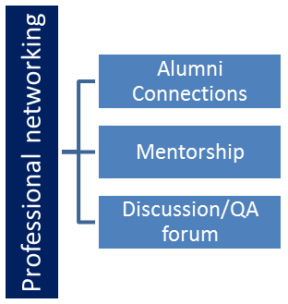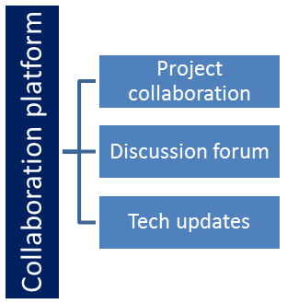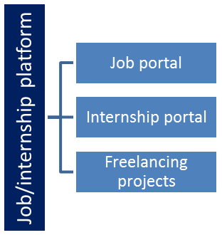

## The IoT Academy

The IoT academy is EdTech Division of UCT that is running long executive certification programs in collaboration with EICT Academy, IITK, IITR and IITG in multiple domains.

## Objectives of this Internship program

The objective for this internship program was to

 ☛ get practical experience of working in the industry.

 ☛ to solve real world problems.

 ☛ to have improved job prospects.

 ☛ to have Improved understanding of our field and its applications.

 ☛ to have Personal growth like better communication and problem solving.

## Reference

[1] Geeks for Geeks: Java

[2] Oracle Corporation. (2021). Java™ Platform, Standard Edition 11 API Specification. Retrieved from <https://docs.oracle.com/en/java/javase/11/docs/api/index.html>

[3] Gupta, P., Jain, N., & Chaturvedi, A. (2017). Object-Oriented Programming with Java. Pearson Education India

## Glossary

|  |  |
| --- | --- |
| Terms | Acronym |
| Expense Tracking Application | A software application designed to help users manage their personal expenses by recording, categorizing, and analyzing their spending habits |
| IoT (Internet of Things | A network of interconnected physical devices embedded with sensors, software, and connectivity, allowing them to collect and exchange data. |
| Category Management | The functionality within the application that enables users to create, modify, and delete expense categories for better organization of their spending. |
| Expense Recording | The process of entering details of individual expenses, including the date, amount, category, and description, into the application. |
| Data Persistence | The ability of the application to store and retain recorded expenses and category information even after the system is restarted. |

# Prolem Statement

# Create a console-based expense tracker application that allows users

**to manage their personal expenses. The application should provide functionalities to record and track expenses, view spending summaries, and manage categories for better organization**

# Existing and Proposed solution

Summary of Existing Solutions and Their Limitations:

Existing solutions for expense tracker applications offer various features and functionalities to help users manage their personal finances. However, many of these solutions have certain limitations that can hinder their effectiveness and user experience. Some of the common limitations are:

1. Mobile-Only Platforms: Some expense tracker applications are designed exclusively for mobile devices, limiting accessibility for users who prefer desktop or web-based interfaces.

2. Limited Customization: Certain applications have limited options for customizing expense categories or reporting formats, which may not cater to users with unique financial needs.

3. Complexity: Some solutions have overly complex interfaces and features, making it challenging for users to quickly record expenses or generate meaningful spending summaries.

4. Data Security Concerns: Users may be hesitant to input sensitive financial information into certain expense tracker apps due to concerns about data security and privacy.

5. Lack of Offline Functionality: Several applications heavily rely on internet connectivity, limiting their usability in areas with poor or no network coverage.

6. Paid Subscriptions: Many expense tracker apps offer only basic features for free, requiring users to subscribe to premium plans for advanced functionalities.

7. No Expense Category Management: Some solutions lack the ability to create and manage custom expense categories, leading to a cluttered expense tracking experience.

8. Inadequate Reporting: The reporting capabilities of certain apps may not provide comprehensive insights or visualizations, limiting users' ability to analyze spending patterns effectively.

9. No Real-Time Synchronization: A few expense tracker applications lack real-time synchronization across devices, resulting in data inconsistencies and delays.

10. Limited Platform Compatibility: Certain solutions may be limited to specific operating systems, excluding users on other platforms from using the app.

Considering the limitations of existing solutions, the proposed console-based expense tracker application aims to address these issues by providing a user-friendly interface, robust data security, extensive customization options, and efficient tracking and reporting functionalities. By offering a versatile and accessible platform, the application seeks to enhance users' ability to manage their personal expenses effectively and efficiently.

**Proposed Solution: Console-Based Expense Tracker Application**

The proposed solution is a console-based expense tracker application that offers a user-friendly and efficient way for individuals to manage their personal finances. The application will be developed using Python programming language to ensure cross-platform compatibility and ease of use.

Key Features:

1. Expense Recording: Users can easily input their expenses, including the date, amount, category, and description, through simple prompts and inputs on the console.

2. Category Management: The application will allow users to create, modify, and delete custom expense categories, providing better organization and personalized tracking.

3. Expense Tracking: Users can view their total expenses for a specified time period or by category, helping them understand their spending habits and patterns.

4. Spending Summaries: The application will generate clear and concise summaries of monthly or category-wise expenses, aiding users in financial analysis.

5. Data Persistence: Recorded expenses and category information will be stored persistently to ensure data integrity and accessibility across sessions.

6. Expense Filtering: Users can filter and view expenses based on specific criteria such as date range, category, or amount, enabling detailed analysis.

7. Real-Time Synchronization: The application will synchronize data across devices in real-time, ensuring consistency and accessibility from anywhere.

8. Error Handling: Robust error handling mechanisms will be implemented to guide users through invalid inputs and handle unexpected scenarios gracefully.

**Advantages:**

1. Accessibility: The console-based approach makes the application accessible to users on various devices and operating systems, including computers and laptops.

2. Simplicity: The user-friendly console interface ensures a simple and intuitive experience, enabling users to record and track expenses effortlessly.

3. Security: Data security will be a priority, ensuring that sensitive financial information remains protected and encrypted.

4. Customization: The application's customizable features will cater to individual preferences and financial habits, providing a personalized expense tracking experience.

Conclusion:

The proposed console-based expense tracker application offers an efficient and user-friendly solution for individuals seeking to manage their personal expenses effectively. By incorporating key features, data security, and cross-platform accessibility, this application aims to empower users with better financial management and insights into their spending habits. With its simplicity and customization options, the proposed solution seeks to elevate the expense tracking experience for users across diverse financial backgrounds.

Value Addition in Planning for the Expense Tracker Application Project:

1. Clear Objectives: Clearly define the goals and purpose of the expense tracker application, ensuring a focused and effective development process.

2. Stakeholder Engagement: Involve end-users and potential users in the planning phase to gather insights and tailor the application to their needs.

3. Risk Assessment: Identify potential challenges in developing and deploying the application, and devise mitigation strategies to ensure smooth execution.

4. Resource Allocation: Optimize the allocation of development resources to ensure efficient project management and timely delivery.

5. Contingency Plans: Plan for unforeseen circumstances or technical challenges, having backup plans to address potential issues.

6. Realistic Timelines: Set achievable milestones and timelines for development to maintain a realistic and sustainable pace.

7. Continuous Monitoring: Regularly monitor progress and gather feedback from stakeholders to make necessary adjustments during development.

8. Adaptability: Be open to incorporating new features or improvements based on user feedback and changing requirements.

9. Innovation and Creativity: Introduce innovative features or approaches to enhance the user experience and stand out from existing solutions.

10. Lessons Learned: Conduct a post-launch review to identify areas for improvement and implement feedback for future iterations.

By focusing on these value addition elements during the planning phase, the Expense Tracker Application project can ensure a well-structured, user-centric, and successful development process.

## Code submission (Github link)

<https://github.com/rishikpatel123/upskill_campus>

## Report submission (Github link) :

## <https://github.com/rishikpatel123/upskill_campus/blob/master/Project%20Report>

# Proposed Design/ Model

## Design Flow: Console-Based Expense Tracker Application

## Project Initiation:

### Define project objectives, goals, and scope.

### Identify key stakeholders and their requirements.

### Formulate the problem statement and project constraints.

## Requirement Gathering and Analysis:

### Engage with potential users and stakeholders to understand their needs.

### Define functional and non-functional requirements for the application.

### Analyze existing expense tracker applications and gather insights into best practices.

## System Design:

### Define the overall system architecture and components.

### Plan the data flow and interactions between different modules.

### Decide on the technologies and tools to be used, such as Python for the console-based interface.

## Database Design:

### Design the database schema to store expense records and category information.

### Determine the database management system to be used (e.g., SQLite).

## User Interface Design:

### Create wireframes and prototypes for the console interface.

### Focus on a user-friendly design with clear prompts and instructions.

### Algorithm Implementation (For DS/ML Students):

### For Data Science/Machine Learning students, this stage involves developing algorithms for generating spending summaries, expense analysis, or budget predictions, if applicable.

## Development:

### Implement the application's core functionalities, such as expense recording, category management, and filtering.

### Develop real-time synchronization mechanisms (if applicable) to update data across devices.

### Testing and Quality Assurance:

### Conduct rigorous testing to identify and rectify bugs and issues.

### Ensure the application meets the defined requirements and user expectations.

## Deployment and User Acceptance:

### Deploy the application to a test environment for user acceptance testing.

### Gather feedback from users and stakeholders to make necessary improvements.

## Final Outcome:

### Deliver the fully functional and tested console-based expense tracker application.

### Ensure documentation and user guides are available for easy adoption.

### Maintenance and Continuous Improvement:

### Monitor the application's performance in real-world usage.

### Address user feedback and implement updates for continuous improvement.

## Throughout the design flow, it's crucial to follow an iterative approach, incorporating feedback and making refinements as needed. This design flow can be adapted to various domains, allowing students and developers to systematically approach their projects, from the initial planning stages to the final outcome, ensuring a well-structured and successful project implementation.

## Interfaces

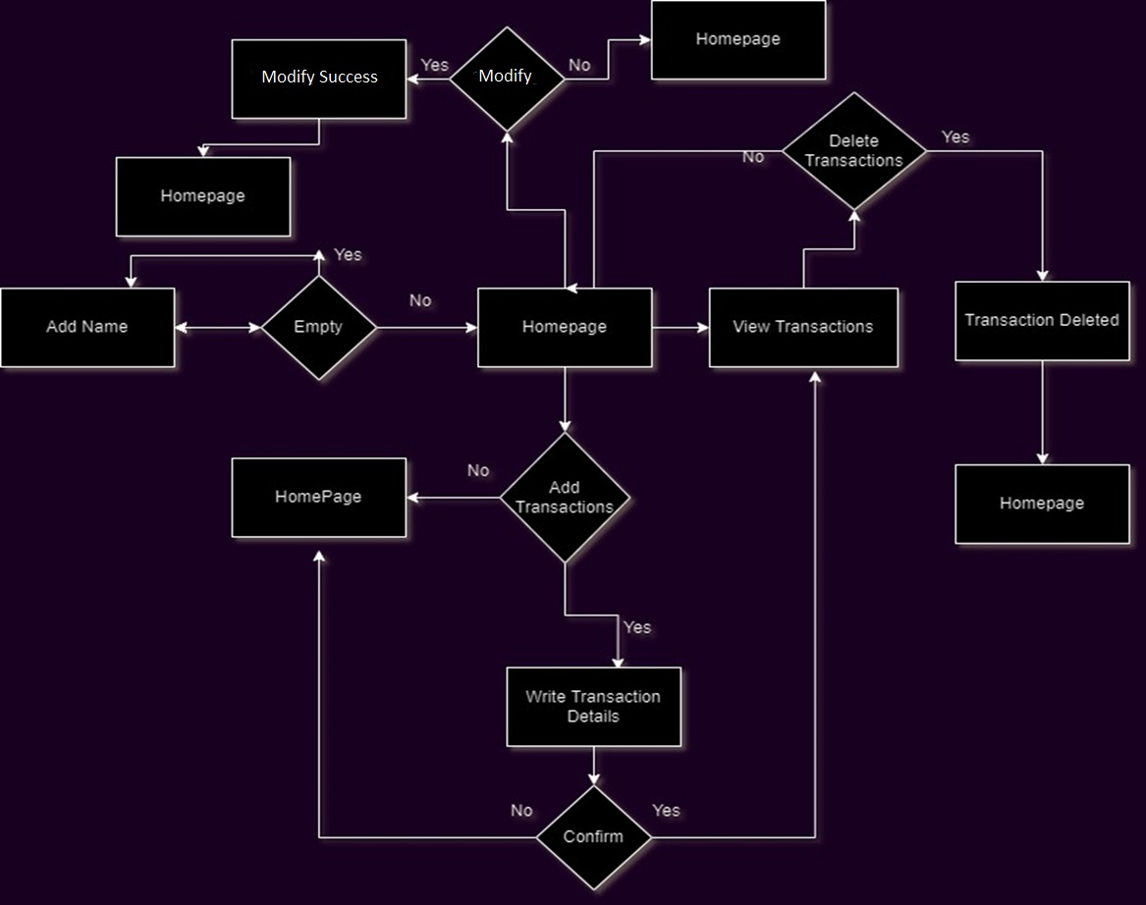

# Performance Test

## Constraints:

## Memory Usage: Due to resource limitations, comprehensive memory usage testing on different desktop configurations was not possible. This may lead to potential memory leaks and inefficiencies.

## CPU Utilization: In-depth CPU stress testing couldn't be performed, impacting the app's performance under high CPU load scenarios.

## Multi-platform Compatibility: Limited multi-platform testing may result in compatibility issues on certain desktop operating systems.

## Recommendations:

## Memory Profiling: Conduct memory profiling to optimize memory usage and address potential leaks.

## CPU Stress Testing: Perform CPU stress tests to ensure smooth performance under heavy load.

## Multi-platform Testing: Test the app on various desktop systems to ensure compatibility.

## Conclusion:

## Though some constraints were not fully tested, adopting the recommended measures will improve the app's performance and user experience on desktops. Continuous testing and optimization are essential for delivering a reliable expense tracker app.

**Test Procedure for Desktop Expense Tracker App:**

Installation and Setup:

## Install the expense tracker app on the target desktop system.

## Launch the app and verify that it opens without errors.

## c. Check if the application's UI components are properly displayed.

## 2. Expense Addition:

## a. Click on the "Add Expense" button and verify that the "Add Expense" frame opens.

## b. Enter valid expense details, including amount, category, description, and date.

## c. Click the "Add" button and ensure the expense is successfully added to the database.

## d. Check if the total expense amount is updated on the main UI.

## Expense Deletion:

## Click on the "Delete Expense" button and verify that the "Delete Expense" frame opens.

## Select an existing expense from the list and click the "Delete" button.

## Confirm the deletion and ensure the expense is removed from the database.

## Check if the total expense amount is updated on the main UI.

## Expense Modification:

## Click on the "Modify" button and verify that the "Modify Expense" frame opens.

## Select an existing expense from the list and modify the amount, category, or description.

## Click the "Save" button and ensure the changes are updated in the database.

## Check if the total expense amount is updated on the main UI.

## Report Generation:

## Click on the "Report" button and verify that the "Expense Report" frame opens.

## Choose a date range and category filter, then click the "Generate Report" button.

## Ensure that the report displays relevant expenses within the selected criteria.

## Memory Usage:

## Monitor the application's memory usage using system monitoring tools.

## Perform multiple actions (addition, deletion, modification) and observe memory consumption.

## Verify that memory usage remains stable and does not exhibit significant leaks.

## CPU Utilization:

## Use system monitoring tools to measure the application's CPU utilization.

## Perform various actions and operations within the app.

## Verify that CPU usage remains within reasonable limits and does not cause high load on the system.

## Multi-platform Compatibility:

## Install and run the app on different desktop operating systems (Windows, macOS, Linux).

## Verify that the app functions smoothly without platform-specific issues.

## Error Handling:

## Intentionally enter invalid data (e.g., negative amount) and observe error messages.

## Verify that the app displays appropriate error messages for different scenarios.

## Performance under Stress:

## Perform stress testing by simulating a large number of expense entries.

## Check if the app remains responsive and stable under the increased load.

## User Interface Responsiveness:

## Interact with various UI elements and ensure they respond promptly to user input.

## Compatibility with Database:

## Verify that the app connects to the database successfully and executes SQL queries.

## Security:

## Validate that the app prevents unauthorized access to sensitive data.

## Cross-browser Testing (If applicable):

## Test the app on popular web browsers to ensure compatibility with web-based components (if any).

# My learnings

**Summary of Overall Learning and Career Growth:**

The Expense Tracker App project, with an integrated MySQL database hosted on an online server, has been an enriching learning experience that will significantly impact my career growth in the following ways:

1. **Database Management and Connectivity:** By working with an online MySQL database, I gained hands-on experience in managing and interacting with databases in a real-world setting. This skill is highly valuable in various roles, including database administrators and back-end developers.

2. **Cloud Hosting:** Hosting the MySQL database on an online server familiarized me with cloud technologies. Understanding how to deploy and manage databases in the cloud is essential in modern software development, as cloud services become increasingly popular.

3. **Scalability and Performance:** Working with an online server allowed me to explore the concepts of scalability and performance optimization. As I progress in my career, these considerations will be crucial when developing applications that need to handle a large number of users or data.

4. **Security and Data Protection**: Managing an online database taught me about the importance of security and data protection. Implementing robust security measures is paramount to safeguarding sensitive user information and complying with data protection regulations.

5. **Application Deployment**: Integrating an online database with the expense tracker app exposed me to the process of deploying applications to production environments. This knowledge is invaluable when launching applications in real-world scenarios.

6. **Remote Collaboration:** Hosting the database online enabled collaboration with team members from different locations. This experience strengthened my ability to work effectively with remote teams, a skill that is increasingly relevant in today's global work environment.

7. **Time Management and Planning:** Managing the development and deployment of the app and database on an online server required meticulous planning and time management. These skills are transferable to any project, ensuring successful and timely delivery.

8**. End-to-End Project Ownership**: Overseeing the entire project, from designing the user interface to deploying the database, gave me a sense of ownership and accountability. This experience fosters a mindset of taking responsibility for the success of the projects I work on in my career.

9. **Real-World Impact:** Developing an expense tracker app with an online database has tangible real-world applications. This project helped me understand how technology can be used to solve practical problems faced by individuals and businesses.

10. **Career Advancement:** The knowledge gained through this project, coupled with the experience of working with an online database, will set me apart in the job market and open up diverse career opportunities in software development, database administration, cloud computing, and more.

In conclusion, the Expense Tracker App project with an integrated MySQL database hosted on an online server has been a pivotal learning experience that has equipped me with a diverse set of skills essential for my career growth. This project serves as a strong foundation for pursuing a successful and fulfilling career in the field of software development and technology.

# Future work scope

**Future Work Scope:**

While developing the Expense Tracker App, certain ideas and features were not implemented due to time limitations. However, these ideas hold great potential for enhancing the app's functionality and user experience. Here are some future work scope ideas that can be pursued:

1. **User Authentication and Security:** Implement user authentication to allow users to create accounts and securely log in. This would enable personalized expense tracking and enhance data security by restricting access to authorized users.

2. **Expense Categories Management:** Add functionality for users to create custom expense categories. This would provide flexibility in categorizing expenses according to their preferences and needs.

3. **Budgeting and Alerts:** Introduce budgeting features that allow users to set spending limits for different expense categories. Implement alerts and notifications to notify users when they exceed their budget limits.

4**. Expense Analysis and Insights**: Incorporate data visualization tools to present users with graphical representations of their expense trends. This would help users gain insights into their spending habits and make informed financial decisions.

5. **Expense Sharing and Splitting**: Enable users to share expenses with others, especially for shared expenses among family members or roommates. Implement expense splitting functionality to distribute shared expenses among multiple users.

6. **Cloud Sync and Backup:** Integrate cloud sync and backup capabilities, allowing users to access their expense data from multiple devices and ensuring data safety through regular backups.

7. **Reminders and Recurring Expenses**: Add reminders for users to enter recurring expenses (e.g., rent, utilities) to streamline expense tracking and avoid missing payments.

8. **Search and Filtering**: Implement search and filtering options to enable users to quickly find specific expenses based on date, category, or amount.

9. **Data Analysis and Trends**: Integrate data analytics features to identify spending trends over time, highlight irregularities, and provide personalized financial recommendations.

10. **Expense Receipt Capture:** Allow users to capture and upload receipts directly through the app, making it easier to store and track physical expense records.

11. **Multi-Currency Support**: Introduce support for multiple currencies, beneficial for users who frequently travel or have international expenses.

12**. Export and Reports**: Offer the ability to export expense data in different formats (e.g., CSV, PDF) and generate customized reports for tax purposes or financial planning.13. Cross-Platform Compatibility: Extend the app's compatibility to other platforms, such as iOS and Android, to reach a wider audience.

13. **Performance Optimization:** Continuously optimize the app's performance to ensure smooth user experience, even with large datasets.

These future work scope ideas have the potential to elevate the Expense Tracker App to a comprehensive and feature-rich financial management tool. Implementing them would further enhance user engagement, attract a broader user base, and solidify the app's position as a valuable tool for personal finance management.